To inform PSI HelpDesk users and Agents

Updates
- For Users (Requesters)
The submission form has been updated as shown below.

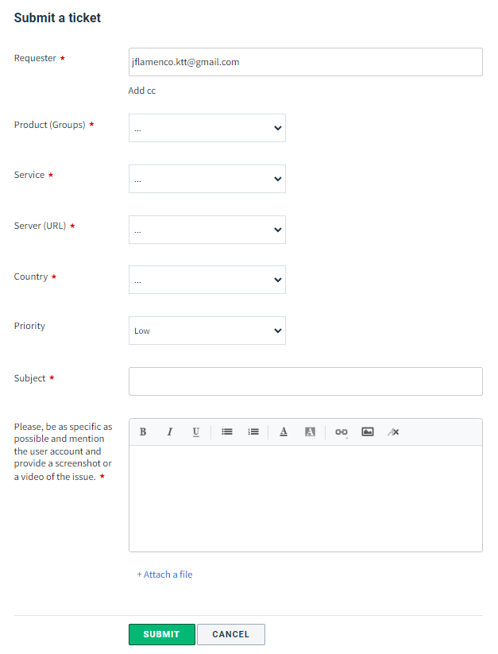

All fields should be filled out to enable the “Submit” button.

To determine the Priority, follow the description below:

Level | Description
Urgent | Impacting PSI field operations or a significant group of users
High | Noncritical but significant issue impacting a single user
Normal | Any issue which is important but does not require immediate action
Low | Issues consisting of any general enquiry about DHM general questions

Take note that priority can be updated by the Agents, once they have received the request and have analyzed the impact of the situation reported.

Product (Groups) have been simplified to make the ticketing submission process easier, the available products as follow:

- RDQA
- HNQIS 2.0
- HNQIS 1.XX (For any legacy HNQIS issues)
- DHIS2 Issues
- DHIS2 Configuration
- DHIS2 Analytics
- Server Configuration (Including but not excluding, DHIS2, FHIR, RapidPro)
- WFA
- ChatBot
- Locator
- PowerBI
- eLearning

As additional projects are undertaken, this product list may change and is subject to be updated if required.

Notice that regardless of the chosen Product (Groups), you will have the following type (or service) of request available:

Bug | A defect or a problem in the system function which results is evidently wrong. Most of the time this kind of service/type requires a Developer intervention. The bugs can manifest in various forms, such as crashes, freezes, incorrect calculations or incorrect output.
Issue | This is a kind of a term which can involve different problems, tasks or functionalities that do not meet the specified requirements, providing an unexpected behavior.
New requirement | Any Product or service that requires update, changes in a specific functionality or a new one. Examples can be:  - A new checklist for HNQIS2  - A new user account in a particular platform or system  - A new Org Unit assigned to a Program in DHIS2  among other similar requests
Other | If there is no certainty of the type of ticket, please use this option

Take note that the subject/description field has enough space to add as much detail as possible, to make the request more clear to the Agents.

- For Agents
As discussed during the call of June 29th, FreshDesk has been reconfigured to facilitate the workflows involved in the different platforms and applications used by the PSI users. This is documented in the HelpDesk Operational Manual- a work in progress that will be completed shortly.

Main updates are as follows
- Group of Products (or Product categories) has been re-built, considering that the platform will serve other applications and systems besides DHIS2, in the middle term. All country specific groups have been removed from the ticket submission form, however, users can still indicate the country this issue is currently happening.
- Agents have been categorized according to Levels identified as Tiers, in a way that the requests coming from the users can be managed in a more efficient way. There are three Tiers, as indicated below

Level | Responsibility | Level of complexity
Tier 1 agent | - Ensures ticket has all necessary information to be triaged and assigned appropriately  - Resolves ticket if possible  - Assigns ticket to the product specific agent and involves any other necessary staff for resolution e.g. M&E advisor, HA advisor, etc. | Basic, this is a common ticket of request that can be resolved by Tier 1 agent
Tier 2 agent | - Investigate and request any other necessary information to resolve the issue  - Propose a solution and guide tier 1 agent on the resolution path | Medium, this is a ticket that requires the intervention of a Tier 2 agent as the problem is more complex
Tier 3 agent | - Investigate and request any other necessary information to resolve the issue  - Propose a solution and guide tier 1 & 2 agent on the resolution path | Difficult, this is a ticket that requires Tier 3 agent, a system architect / developers to resolve

- Automations. Based on the products and Agents Tiers, rules have been defined to guarantee the SLA is respected according to what PSI requires and the Users receive appropriate responses in the expected lapsus indicated in the SLA.
- The Requests submission form has been updated (see the image above).
- Previous / Opened tickets have been reclassified. This is transparent for the User and should not hinder existing ticketing process

