Zimbabwe Ministry of Health
Health Network Quality Improvement System
(HNQIS)
Server Technical Specification Document

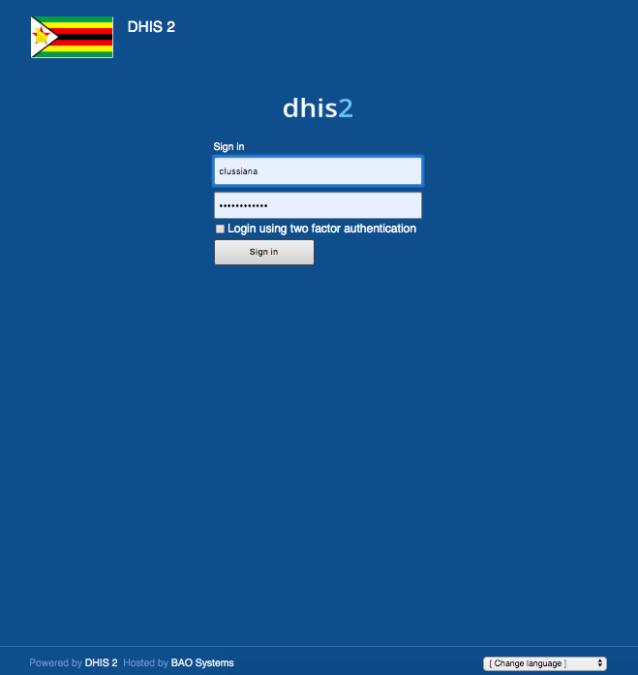

Prepared by:
- Doreen Wamiti: dwamiti@psi.org
- Ruth Mwende: rmwende@psi.org

Table of Contents

Background 3
Servers 3
User roles 3
Users 4
User groups 4
OUs 5
OU tree 5
HNQIS Programs 6
HNQIS Configuration 7
HNQIS Analytics 7
Helpdesk 10
How do I get help from Helpdesk? 10
Known bugs 11
Annex 1 – How to create User account for Data Analytics 12
Annex 2 – How to create User account for Data Entry 15

Background
- Dedicated DHIS2 instance for the Zimbabwe Ministry of Health to collect data from supportive supervision visits conducted with Population Services International (PSI)’s HNQIS app
- PSI/Zimbabwe is the supporting implementing partner
- In-country DHIS2 System Admin:
  - Rangarirai Gava: rgava@psi.org.zw
- Remote PSI Global Business Systems (GBS) support:
  - Doreen Wamiti: dwamiti@psi.org
  - Ruth Mwende: rmwende@psi.org

Servers
- Development server: https://clone-zw.hnqis.org (dhis version 2.30)
  - Server hosted by BAO Systems on a ST-4 plan started in Sep 2018
  - Analytics run hourly
- Production: https://zw.hnqis.org (dhis version 2.30):
  - Server hosted by BAO Systems on a ST-4 plan started in Sep 2018
  - Analytics run hourly

User roles
Name | Details
_Admin - Data Elements (Private) | Create and edit DEs (private sharing)
_Admin - Data Elements (Public) | Create and edit DEs (public sharing)
_Admin - Data Quality | Run Validation rules
_Admin - Indicators management (Private) | Create, edit and manage Indicators
_Admin - Legends | Create, edit and manage Legends and Legend items
_Admin - Option Set Management (Private) | Create, edit and manage Option sets
_Admin - Org Unit admin advanced | Create, edit and manage OU levels and perform OU hierarchy operations
_Admin - Org Units (Basic) | Create, edit and manage OUs
_Admin - Program Management (Private) | Create, edit and manage Event Programs
_Admin - Program Org Units | Assign and manage OUs to Programs
_Admin - Tracker Management | Create, edit and manage Tracker Programs
_Admin - User Management advanced | Create, edit and manage Users
_Analytics - Dashboard only | Access to DHIS2 dashboards, only
_Analytics - Services (all) | Full access to all of DHIS2 analytical tools
_App - Browser cache cleaner | Clear DHIS2 browser cache
_User - Data Entry Tracker | Data entry for Event and Tracker Programs (Event Capture, Tracker Capture, DHIS2 Android Capture)
Superuser | Full access to all DHIS2 roles

Users
- Demo account for HNQIS Data entry and Analytics (all HNQIS Programs):
  - https://zw.hnqis.org
  - ZWdemo; Zimbabwedemo1!
- HNQIS users to add to the relevant User group(s) based on what type of Data entry they are expected to do:
  - Example: in case a user is expected to conduct supportive supervision visits on Cervical Cancer, s/he needs to be added to the User group ZW HNQIS CC. Also, he needs to be assigned to the right OUs for Data capture and maintenance org units
- For more information on HNQIS System Admin, refer to the HNQIS System Admin manual loaded as a Resource in the server (Reports -> Resource)
- Here are links to user manuals for creating a data entry account and analytics user.

User groups
Name | Details
ZW - HNQIS Admin | User group for HNQIS Admins: metadata = edit and view, data = capture and view
ZW HNQIS MASTER | User group for data entry to all HNQIS programs: metadata = view, data = capture and view
ZW HNQIS ART | User group for HNQIS ART Data entry: metadata = view, only, data = capture and view
ZW HNQIS CC | User group for HNQIS CC Data entry: metadata = view, only, data = capture and view
ZW HNQIS FP | User group for HNQIS FP Data entry: metadata = view, only, data = capture and view
ZW HNQIS HTS | User group for HNQIS HTS Data entry: metadata = view, only, data = capture and view
ZW HNQIS STI | User group for HNQIS STI Data entry: metadata = view, only, data = capture and view
ZW HNQIS VMMC | User group for HNQIS VMMC Data entry: metadata = view, only, data = capture and view
ZW HNQIS VWAG | User group for HNQIS GBV Data entry: metadata = view, only, data = capture and view
ZW HNQIS WEA | User group for HNQIS WEA Data entry: metadata = view, only, data = capture and view
_PROGRAM_ZW HNQIS ifoche | User group for BAO developers to troubleshoot: metadata = edit and view, data = capture and view

OUs
Number of Organization units for the various levels:
- Subnational Level 1 Country – 1
- Subnational Level 2 Province – 10
- Subnational Level 3 District – 61
- Subnational Level 4 Sub – Districts/Wards/Municipalities/Health Facilities – 2263
- Subnational Level 5 IPC agents. Health Providers – 81

OU tree
Root | Subnational level 1 | Subnational level 2 | Subnational level 3 | Subnational level 4 | Subnational level 5
Region | Country | Province | District | Sub-districts / Wards / Municipalities / Health facilities | IPC agents / Health providers
Ex:
Southern Africa | Zimbabwe | Harare | Harare | Kuwadzana Phase 4 -101851- Clinic | DFO - Samanatha Kumbula (ZW_101470)

HNQIS Programs
All HNQIS Programs are shared with the User group ZW – HNQIS Admins (metadata = edit and view, data = capture and view) and ZW HNQIS Master (metadata = view only, data = capture and view).
Also, HNQIS Programs are shared with the relevant User group(s) for Data entry as per table below: e.g For ZW HNQIS Family Planning Counseling program it should be shared with the user groups ZW – HNQIS Admin, ZW – HNQIS Master and ZW HNQIS FP. If a Quality Assurance Officer (QAO) is working on the FP program, the QAO should be added to the ZW HNQIS FP User group, so that they s/he is able to access the FP HNQIS Programs.

Health Area | Program Name | User group for Data entry
CC | ZW HNQIS Cervical Cancer | ZW HNQIS CC
FP CFC | ZW HNQIS Family Planning Counseling | ZW HNQIS FP
FP LAM | ZW HNQIS Family Planning Long Acting Methods | ZW HNQIS FP
FP SAM | ZW HNQIS Family Planning Short Acting Methods | ZW HNQIS FP
HIV ART | ZW HNQIS HIV ART Nurse Counselor Supervision Tool | ZW HNQIS ART
HIV CAT | ZW HNQIS HIV Care and Treatment | ZW HNQIS ART
GBV | ZW HNQIS HIV Gender Based Violence | ZW HNQIS VWAG
HIV ICT | ZW HNQIS HIV Index Case Tracing Supervision Tool-Index Nurse Supervision | ZW HNQIS HTS
HIV LSNC | ZW HNQIS HIV Laboratory Scientist/Nurse Counselor Tool | ZW HNQIS HTS
HIV NOD | ZW HNQIS HIV New Start Office Assistant/Driver Supervision Tool | ZW HNQIS HTS
HIV NRD | ZW HNQIS HIV New Start Receptionist/Driver Supervision Tool | ZW HNQIS HTS
HIV TCSV | ZW HNQIS HIV Testing and Counseling Supervision Tool | ZW HNQIS HTS
HIV TCSA | ZW HNQIS HIV Testing and Counselling Site Assessment | ZW HNQIS HTS
STI v2 | ZW HNQIS Sexually Transmitted Infections v2 | ZW HNQIS STI
VMMC CRR | ZW HNQIS VMMC: Client Record Review | ZW HNQIS VMMC
VMMC COM | ZW HNQIS VMMC: Communication to Clients | ZW HNQIS VMMC
VMMC FAC | ZW HNQIS VMMC: Facilities, Supplies, Equipment, and Emergency Management | ZW HNQIS VMMC
VMMC SOP | ZW HNQIS VMMC: SOPs, Guidelines, Policies, Job Aids and Adequacy of Staffing | ZW HNQIS VMMC
VMMC PRC | ZW HNQIS VMMC: Surgical Equipment and Procedures, and Prepex Device Procedures | ZW HNQIS VMMC
WEA | ZW HNQIS Work Environment Assessment | ZW HNQIS WEA

HNQIS Configuration
- Prioritization matrix:
  - Server dependent and customizable. For the server https://zw.hnqis.org, the prioritization matrix used by the HNQIS app to schedule the date of the next supportive supervision visit is as follows:
    - +1 month in case the Quality of Care (QoC) score is below 90%
    - +6 months in case the Quality of Care (QoC) score is equal to or greater than 90%

HNQIS Analytics
- For each HNQIS Program, we have:
  - Event data items by health area: these are Data elements (DEs) and they compose the HNQIS Programs. They store the values collected during supportive supervision visits.
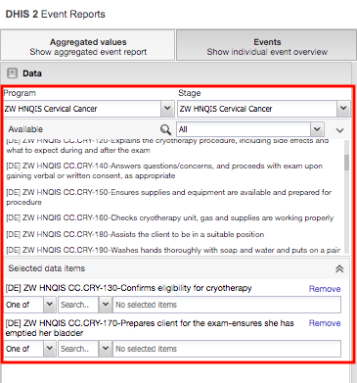
  - Program indicators:
    - Count: they store the number of assessments conducted by Health Area
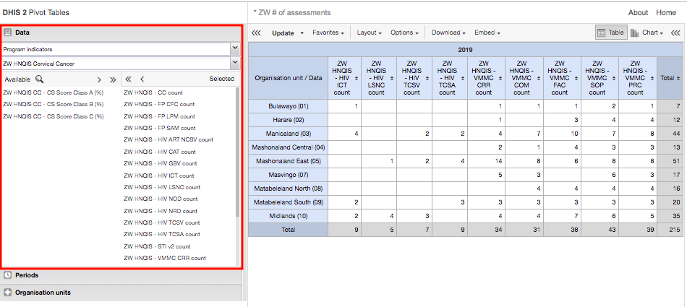
    - % Class A, B and C: they store the percentage of assessments which fall in Class A, B and C based on the QoC score, where Class A is
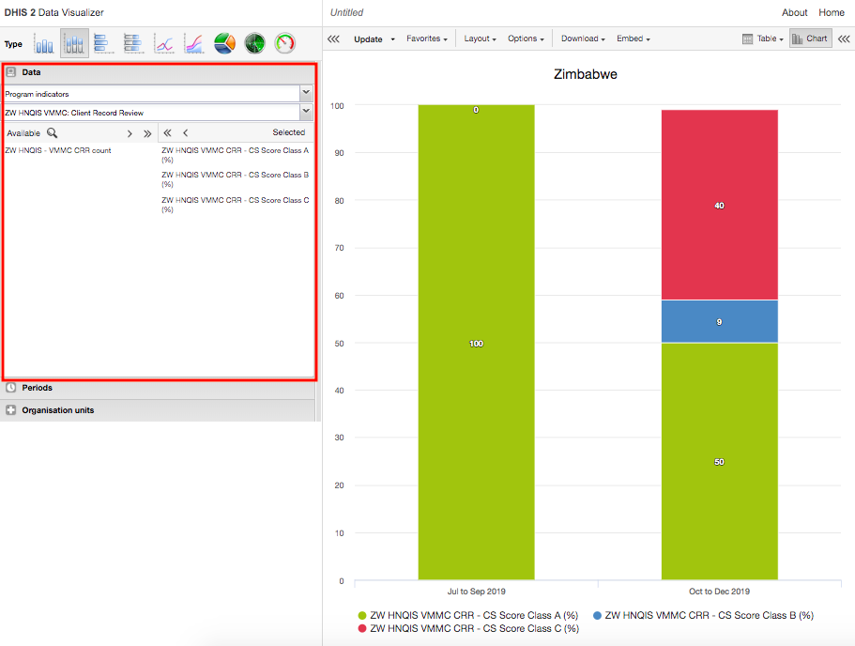
- Note on Maps:
  - Users are now able to analyze data on maps thanks to the availability of shape files for Zimbabwe administrative regions. 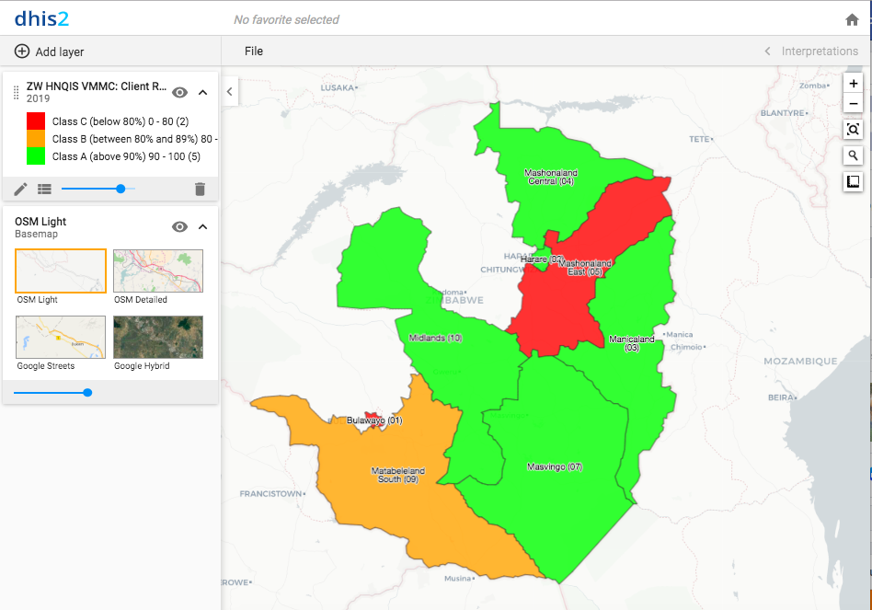

Helpdesk
- The Helpdesk is a platform that allows users to get assistance in issues they come across in the server and the HNQIS app. PSI-MIS Helpdesk will help users to:
  - Submit any issue they are experiencing to get timely support
  - View the status of your submitted tickets to track progress on their resolution
  - Request for new features and functionality
  - Learn how to handle tasks through the knowledge base articles from the solutions page
  - Search for answers for frequently asked questions (FAQs)

How do I get help from Helpdesk?
- Go to the PSI-MIS Helpdesk page at: https://helppsi.freshdesk.com/
- Click on the new support ticket
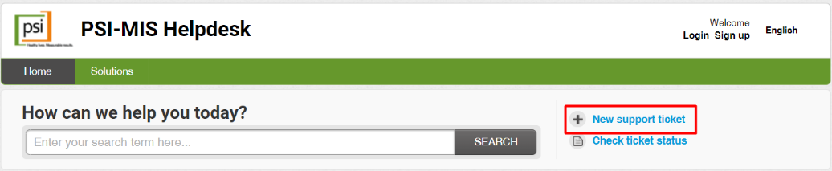
- Fill in the ticket details as per the form
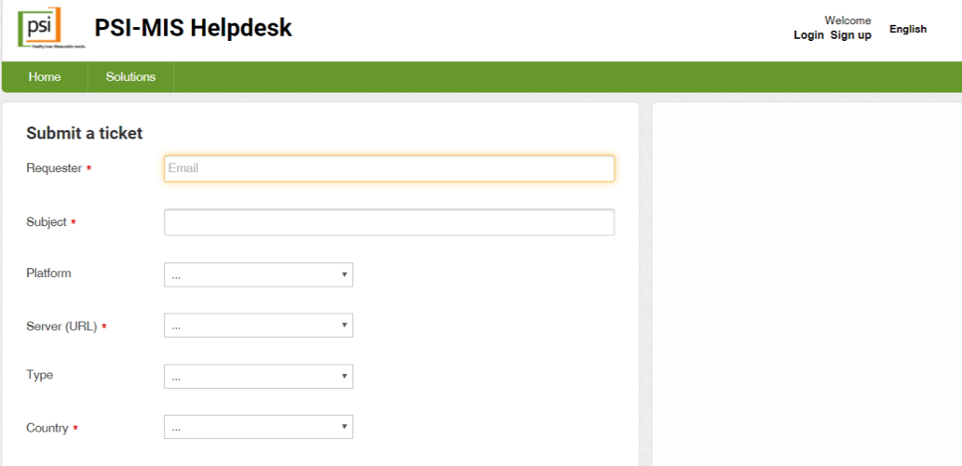
  - Requester - your email address
  - Subject - the subject of your ticket
  - Server - choose the server on which you are experiencing the issue on, e.g. https://zw.hnqis.org
  - Country - specify your country or select NA if not applicable
  - Ticket type - choose Configuration, Maintenance, Question, Bug, Other depending on the ticket type
  - Describe your issue in details and be as specific as possible
  - Attach a file – Use this to add any relevant files or screenshots of the full screen to assist in resolving the issue
  - Click on Submit

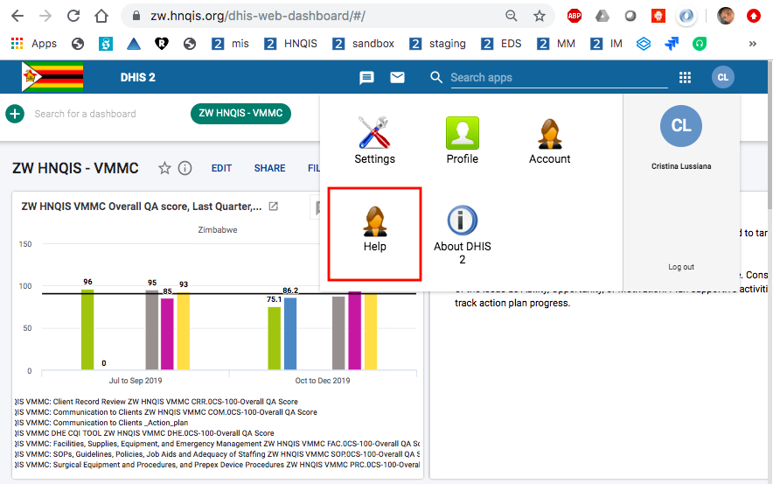
- Another option to access the PSI-MIS Helpdesk page is from the DHIS2 ‘Help’ app from your account menu:

Known bugs
- Users app: Users cannot see / edit users they have created themselves
  - This bug has been fixed. This occurs if you do not select an OU for the user.
  - As a consequence of this bug, we have several users in the server with the same name and surname and different usernames. Ranga to clean up
- Dashboard app: Unable to add items to a dashboard
  - Weird behavior, not always replicable. The University of Oslo is working to fix it.
- Multiple legends not rendering in PT

Annex 1 – How to create User account for Data Analytics

Open DHIS2 App. Select Users app

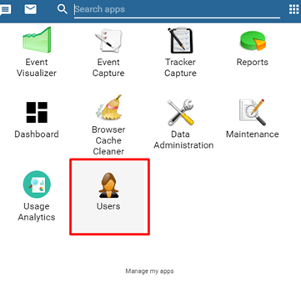

Click on the + add on the Users Card.
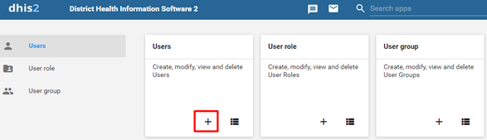

Fill in the mandatory fields as shown below i.e Username, Password, Surname and First name.

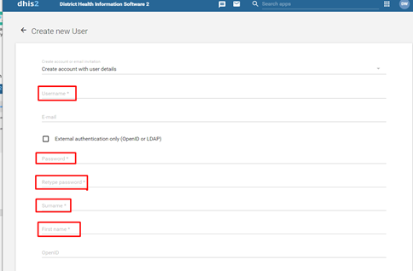

In the Available roles section, double-click on the Analytics – Services (all) role to assign the role

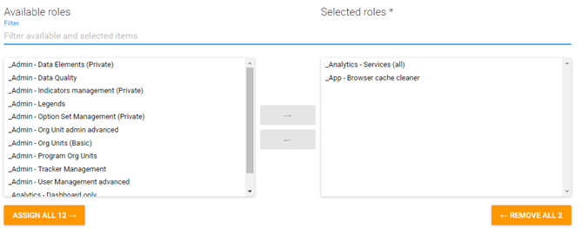

From the Data capture and maintenance organization units, select the relevant OUs for Data Entry (or _Test ZW) and relevant OUs for data analysis from Zimbabwe.

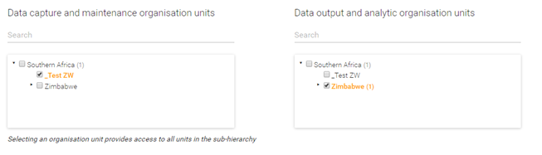

Click on Show more options at the bottom of the page to display additional options

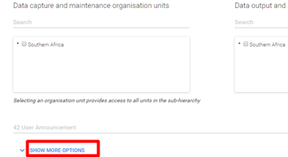

From Available user groups section, select the relevant user groups as per Access model.

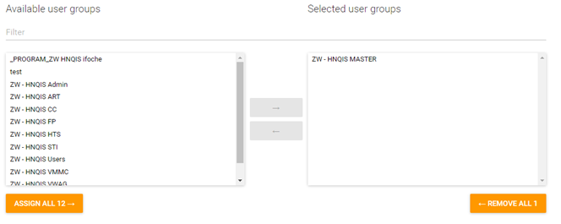

Click Save.

Annex 2 – How to create User account for Data Entry

Open DHIS2 App. Select Users app.
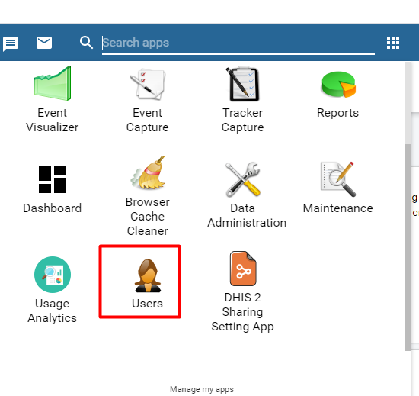

Click on the + add on the Users Card.

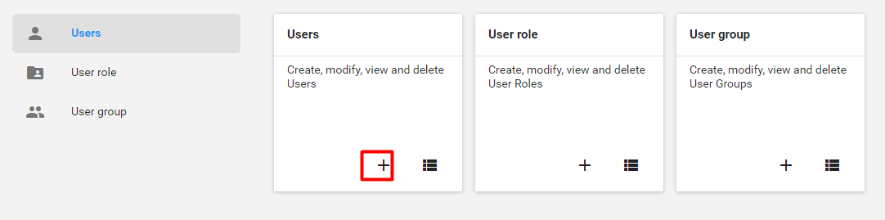

Fill in the mandatory fields as shown below i.e Username, Password, Surname and First name.

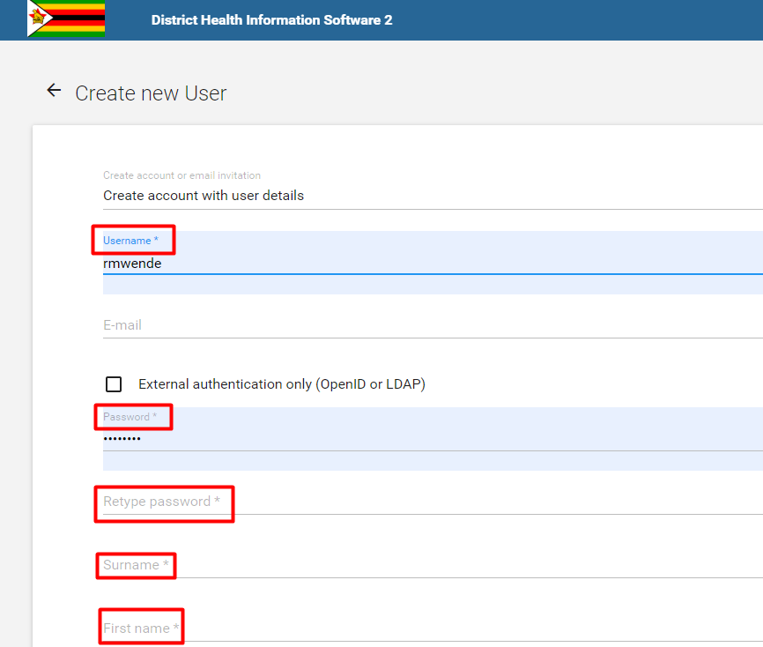

In the Available roles section, double-click on the _User - Data Entry Tracker role to assign the role (this is for Data entry for Tracker programs, like HNQIS Programs).
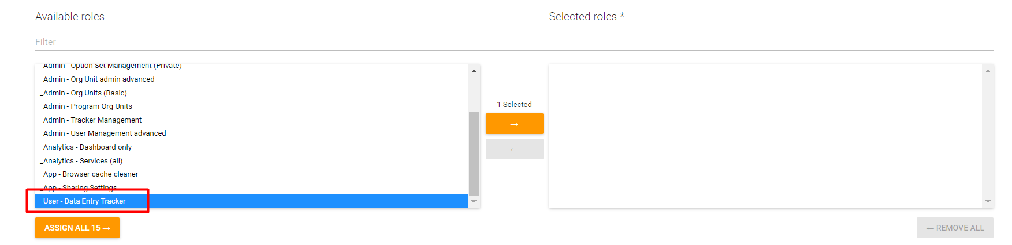

From the Data capture and maintenance organization units, select the relevant OUs for Data Entry.

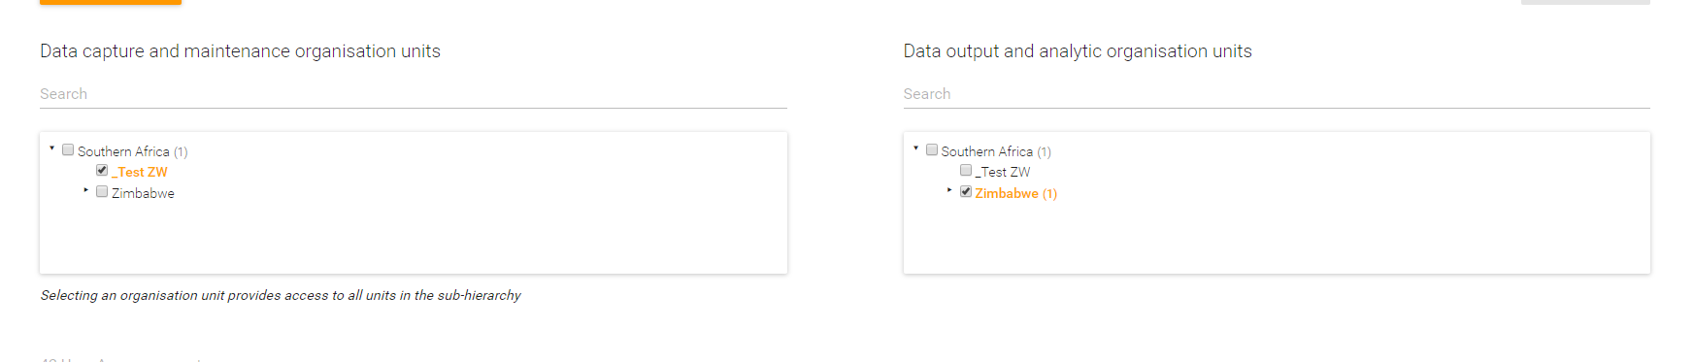

Click on Show more options at the bottom of the page to display additional options.

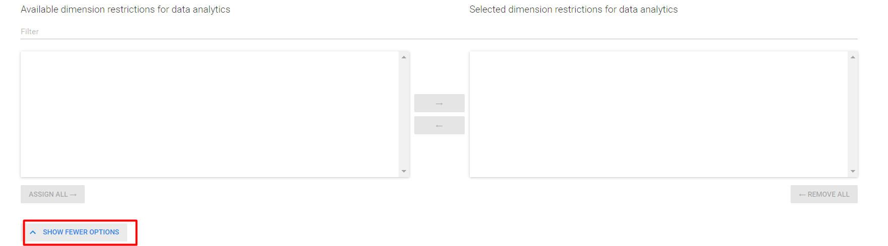

From Available user groups section, select the relevant user groups as per Access model.

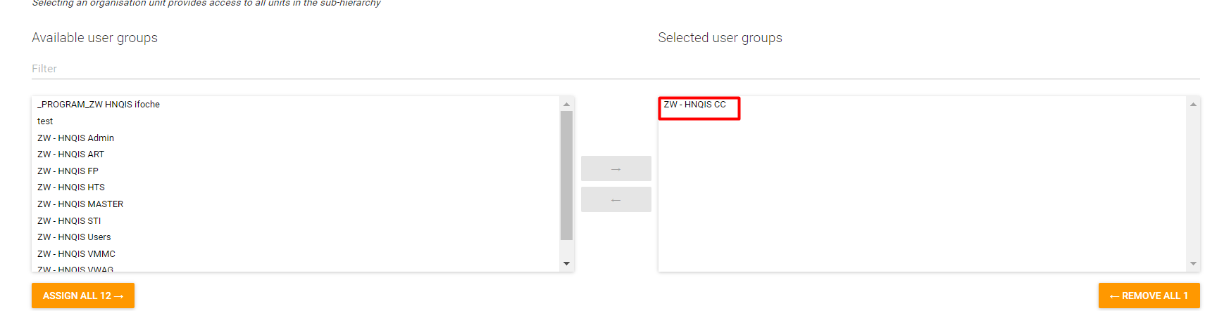

Click Save.

https://play.google.com/store/apps/details?id=org.eyeseetea.malariacare.hnqis_ng

